TITLE OF PAPER

Name SURNAME; …; Name SURNAME

Abstract: Calibri Italic 12 pt. (150-200 words)

Keywords: 4-6 keywords.

Body text

It should consist of following: 1. Introduction; 2. Methods; 3. Experimental; 4. Conclusion, 5. References, Acknowledgments.

Information

Use DIN A4 format. A single column layout is used. The margin settings are all equal at 2 cm on Left, Right, Top and Bottom of the page. The main body of the text is in Calibri 12 pt, justified. Paragraphs must be separated by one line space (10 pt).

Titles and subtitles

For titles of chapters use the “Heading 1” style Calibri Bold 14 pt. For subtitles of chapters use the “Heading 2” style Calibri 14 pt.

Graphic Material

Figures should be set into the body of the text at appropriate point. Place the pictures between paragraphs and centre them between the margins. Figures layout should be in line with text. They should be labelled in sequence with the other figures. Figures must be made in high quality, which is suitable for reproduction and print.

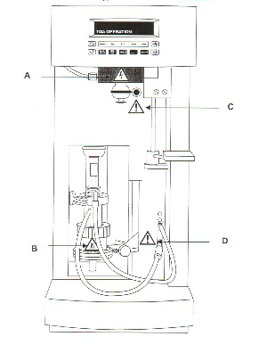 | 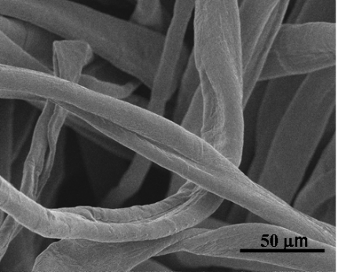
a. | b.
Figure 2: Title of figure (max. three pictures across the width of the page, arranged as element of a table.): Description of a, b, and c.

References

References should be indicated on the text by a sequence number in square brackets [1]. They should be numbered in the order in which they appear in the text.

- Surname, N.; Surname, N.: Name of Book (in Italics), Publisher, ISBN, Place of Publication, (YYYY)
- Surname, N. & Surname, N.: Name of paper or Chapter, In Name of Book (in Italics), Publisher, ISBN, Place of Publication, (YYYY), pp. xxx-yyy
- Surname, N.; Surname, N. & Surname, N.: Title of conference paper, Proceedings of xxx xxx, Surname, N. (Ed.), pp. xxx-yyy, ISBN, conference location, Month and Year, Publisher, City, (YYYY)
- Surname, N.: Name of paper, Name of Journal (in Italics), Vol. (YYYY) No., pp. xxx-yyy, ISSN
- Surname, N.; Surname N. & Surname N.: Name of Paper, Available from http://www.exact-address-of-site Accessed: YYYY-MM-DD

