TEKSTILNO-TEHNOLOŠKI FAKULTET
SVEUČILIŠTE U ZAGREBU
BARUNA FILIPOVIĆA 28 A
ZAGREB

POZIVAMO VAS NA PREDSTAVLJANJE KNJIGA
prof.dr.sc. ŽARKA PAIĆA

AESTHETICS AND THE ICONOCLASM OF CONTEMPORARY ART, Springer International Publishing, 2021
THE SPHERES OF EXISTENCE – THREE STUDIES ON KIERKEGAARD, Toronto University – Kierkegaard Institute, 2021
ART AND THE TECHNOSPHERE – THE PLATFORMS OF STRINGS, Cambridge Scholars Publishing, 2022
Ed. THE TECHNOSPHERE AS A NEW AESTHETIC, Cambridge Scholars Publishing, 2022
Ed. FASHION THEORY AND THE VISUAL SEMIOTICS OF THE BODY, Cambridge Scholars Publishing, 2022
Uvodna riječ
Dekanica, izv.prof.dr.sc. Anica Hursa Šajatović
O knjigama govore
izv.prof.dr.sc. Nina Katarina Simončič, doc.dr.sc. Tonči Valentić, dr.sc. Petra Krpan i prof.dr.sc. Žarko Paić

Ponedjeljak 17. listopada 2022. u 14 sati
Dvorana A-201
Radujemo se Vašem dolasku

Aesthetics and the Iconoclasm of Contemporary Art
The main themes and aims of this book are understanding aesthetics, contemporary art and the end of the avant-garde not from the traditional viewpoint of the metaphysics of the beautiful and the sublime but rather thru close connection to the techno-genesis of virtual worlds. This book tackles problems in contemporary art theory such as the body in space and time of digital technologies, along with other issues in visual studies and image science. Further intentions exhibit the fundamental reasons for the disappearance of the picture in the era of virtual reality starting from the notion of contemporary art as realized iconoclasm; art has no world for its “image”. The author argues that the iconoclasm of contemporary art has severe consequences. This text appeals to philosophers of art and those interested in contemporary art theory.

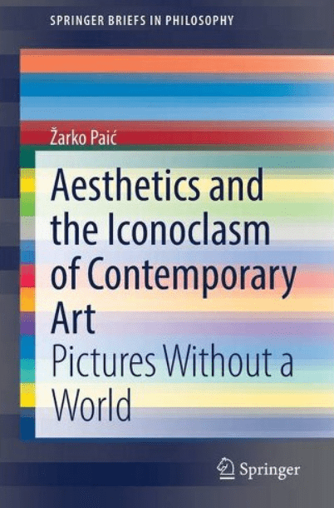

The Technosphere as a New Aesthetic
This edited collection, dedicated to the issue of Homo Kybernetes, sheds light on the genesis and development of opinions about the technosphere as an aesthetic problem par excellence from different points of view. In this sense, the contributions here reflect not only on the cybernetic way of thinking as a condition of the possibility of digital aesthetics, but also on the possibilities of the transition of human sensibility to a different way of bodily existence, starting from transhumanism and the posthuman condition.

Art and the Technosphere: The Platforms of Strings

In the analysis of the relationship between aesthetics and contemporary art, this book investigates hermeneutics, phenomenology and semiotics when it comes to the notion of the image and its new status concerning avant-garde art, which went in the direction of the analysis of posthumanism/transhumanism. Showing that we must begin to think of the aesthetic construction of the worlds, rather than representing the idea in its eternity, it explains that contemporary art from avant-garde procedures of shock, provocation and experiment enters the area of the metatheory of visualization of the event. From the caves, temples, and cathedrals to the museums of contemporary art and, finally, to the event of creation and enjoyment in a digital simulation, a circle of the historical development of art is closed. The problem is no longer about “what” art is, but “how” we should determine the difference between the aesthetic object and artificial life.

Fashion Theory and the Visual Semiotics of the Body
Instead of the logic of representation of fashion in the light of modern society and postmodern culture, this book argues that contemporary fashion should be regarded as a performative-conceptual turn in the very core of body iconograms. The text presents a theoretical perspective of the phenomenon of fashion within fashion theory as establishing a new approach from visual semiotics. Through this lens, fashion, therefore, emerges as a visual code of contemporary societies and cultures in the networked matrices of hyperreality and visions of that coming time that will determine the combination of cybernetics, fetishism and transgression.

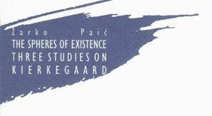 Author try to show the relationship between Kierkegaard and contemporary philosophical issues as existential faith concerning the already overshadowed horizon within which the concepts of »mind« and »faith« are again discussed. Kierkegaard’s three spheres of spiritual Being ─ aesthetic, ethical, and religious ─ come to mind with the question of the boundaries between thinking and belief about the very occurrence of what is no longer a Being or the beings, neither alive nor dead. How to approach it? Kierkegaard’s contribution to the thinking of Being can be solved as a question of the subject of »philosophical faith«. It seems that such faith belongs to the future. Beyond all spheres lies a pure and spiritual place. Is it a habitus of God which can only be confirmed by »philosophical faith« in the event? In addition, should one finally abandon any possible »faith« to get a »faith« which no longer thinks of the openness of the historical event, but an event beyond the difference between philosophy and faith? An analysis shows that neither Jaspers’ attempt to establish a new »philosophy of faith« in existence, nor the restoration of the traditional opposition to thinking and belief in a contingent event, the power of technosphere in the creation of an artificial mind and artificial life as a result of the construction of a subject, reach the pure event itself. Instead, we should see whether it is possible to think about technosphere even in the form of metaphysical thinking of the aesthetic-ethical-religious criticism appropriate to absolute science in the shaping of inhumanity today.

